RC tutorial 003 - Creating your own alignment geometry

===================================================

Revised 2019-09-30

* This tutorial's goal is to teach you < the subject here>.
* Assumed RailCOMPLETE skills: Previous lessons..
* Assumed railway skills: You know about You know about railway geometry - lines, arcs and spirals (clothoids) in the XY plane.
* Time to spend here: 1 hour.
* Notice to users with non-English versions of AutoCAD – see footnote[1].
* This tutorial was prepared using software release 2018.22.1284 with Norwegian DNA version “2019.1 gamma”,” NO-BN;NO-0001;2019-09-28T20:19:00+01:00;2019.1”.
* Note: If you are using AutoCAD version 2017 or older, then open the 2013-format version of the tutorial DWG file.

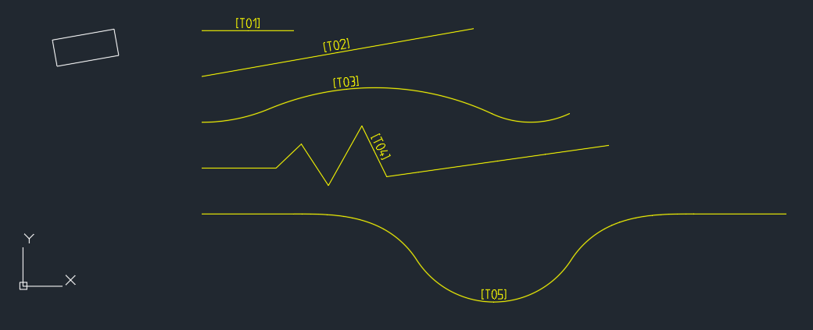

1. Start AutoCAD with RailCOMPLETE, then open the ‘General Tutorials’ folder and locate the DWG file named after this tutorial. You can either type RC-ShowGeneralTutorials or you can locate the button below the RC logo in the upper left corner of your AutoCAD window.
2. Activate the RC-ShowGeometry tool to see your changes directly in modelspace while you make modifications to the alignment, and the alignment is selected.
3. T01 - Straightline track

a- Use F8 to activate the AutoCAD Ortho drawing mode

b- Start RC-CreateAlignment with a railway track as object type, then click where you want pos 0 to start

c- The function always starts in LINE mode. You can see the other available modes (CURVE and SPIRAL) by pressing the 'Down' key

d- Enter 'L' (Length) and enter '90'. A preview is shown of a railway track being straight and 90 m long

e- Re-enter 'L' and enter this time '70'. The preview changes to a 70 m long track

f- Repeat again, enter 'L' and '100'. The preview shows a 100 m long track. Accept this segment by LEFT-clicking once

g- Then finish the alignment by RIGHT-clicking, and give it value 'T01' for its property @code

h- RailCOMPLETE starts over again with a new alignment ('Specify first point...'), press ESC to exit the command

i- Start the RC-ManageProperties (the Property Manager) and check the alignment's code ('T01') and type ('spor').

j- Activate RC-ShowAlignmentName to see the track's name, when selected.

k- Save your work as DWG (QSAVE or CLOSE or SAVE or SAVEAS).

l- Save your work in LandXML format as well, for exhange with other railway softwares, using RC-ExportLandXmlAlignments.

m- Open a virgin DWG file, start it as a RailCOMPLETE document, and use RC-ImportLandXmlAlignments to reimport your tracks.

1. T02 - Straight 300m long track, drawn at a given angle in the XY-plane

a- Toggle off ortho mode (F8), then start RC-CreateAlignment with a railway track type ('spor')

b- Set the start direction using the Down key and selection "startDirection", or press D then ENTER. Then point out the drection by clicking twice in modelspace. Use AutoCAD snapping and point out a vector along the side of the inclined rectangle shown above.

c- Set the Length to 300, then end that segment with left-click and finish the alignment with right-click, call it 'T02'.

d- In Alignment Manager, check the 'Bind to Selection' box at your lower left. This has the effect that whenever you select an alignment in modelspace, it will also be marked in the Alignment Manager, and vice versa.

1. T03 - Curved multi-segment track

a- Start drawing a railway track ('spor') along the X-axis, a circular curve (press 'C' and ENTER), set Radius to 190 and Length to 75, move your CAD cursor to see a CCW curve, and left-click to accept this first segment.

b- Then move your cursor to point out a continued CW curve, press R and change radius to 300, set Length to 250 and left-click.

c- Continue drawing a R=100 CCW curve, and set enddirectioN ('N') to 25 degrees, then accept the segment with a left-click

d- Finish with right-click and call it 'T03'

1. T04 - Straight track consisting of several zig-zag segments

------------------------------------------------------

a- Start drawing a railway track ('spor'), accept the first segment, then left click a few times and you'll see a zig-zagged line

b- Then press F (for 'diFferentiable') and select 1 (=true). You are now in a mode where each new segment starts with the previous segment's end direction

c- Move your CAD cursor and left-click a few times - you will see that each new segment has the same direction as the previous.

1. T05 - Straight line, clothoid and circular curve

-------------------------------------------

a- Start out with drawing a 100 m straight line segment ('Tangent') along the positive X-axis direction, accept it with left-click

b- Then switch to Spiral mode (clothoids), set the clothoid parameter A = sqrt(R*L) to 100 and its length to 100.

c- Then the end radius automatically ends up with R = A*A/L = 100

d- Move your cursor to define a CW clothoid, accept this spiral with left-click

e- Then switch to Curve mode and set Length to 50, left-click to accept a CW curve (radius is still 100)

f- Then continue directly into a CCW curve of radius 100 for 200 meters, left-click to accept,

g- Then make a 50 m long CW curve with radius 100,

g- Switch back to Spiral mode and set Endradius to 0 (meaning 'Infinity', i.e. tangent line), accept it,

h- Continue in Tangent line mode, switch on diFferentiable mode, set length to 100m accept it,

i.- Then finish the alignment with right-click and call it 'T05'.

Please check our website www.railcomplete.com for updates.

Corrections and suggestions are welcome to support@railcomplete.no.

Thank you for using RC Tutorials!

1. Your AutoCAD session has probably been started from a Windows shortcut of the type:  
   “C:\Program Files\Autodesk\AutoCAD 2019\acad.exe” /product ACAD /language “fr-FR”  
   (“fr-FR” means “French language, France’s version) similar. Native AutoCAD commands may have different names in your language pack, other than the COPY, COPYBASE, FIND etc that you see in our tutorial texts. In order to instruct AutoCAD to accept the native English command name, precede the native (English) command name by an underscore character, ‘_’. For instance: ‘_FIND’ will start AutoCAD’s native ‘FIND’ command even if you are using AutoCAD with the French language pack, where the command in French is called ‘RECHERCHER’.If a command needs an argument ‘ON’, and the French menu says ‘Allumer’, then you can enter ‘_ON’ to instruct AutoCAD to use the option’s native name.